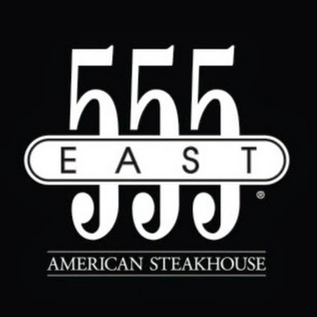
555 East American Steakhouse
555 E. Ocean Blvd, Long Beach, CA
562-437-0626
555 East is a traditional steakhouse restaurant with traditional wood & leather décor. While they are known for their high-quality, buttery steaks and fresh seafood, they have a variety of options for different tastes that can all be easily paired with something from their extensive wine list. They also offer vegetarian and gluten-free options.
Average Cost of Meals: $15-98
Distance from Westin Long Beach Hotel: 0.1 mile

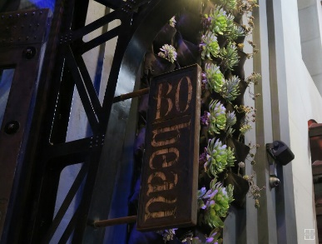
Bo-beau
144 Pine Ave, Long Beach, CA
562-983-0056
Bo-beau is a French Cuisine Kitchen and Roof Tap. This is a large restaurant with a bi-level gastropub for bar fare and beer, a formal dining space and a rooftop patio featuring a unique beer garden. They serve everything from pub food to steak to pasta and more! There are gluten free and vegetarian options.
Average Cost of Meals: $18-32
Distance from Westin Long Beach Hotel: 0.4 mile
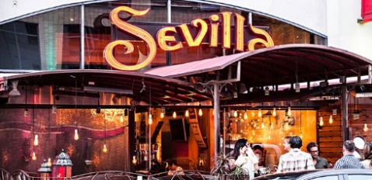
Sevilla
140 Pine Avenue, Long Beach, CA
562-495-1111
Café Seville is a Spanish restaurant known for its delicious food, salsa dancing classes and authentic tapas bar. They market their restaurant as “A trip to Spain without the airfare”. They have casual outdoor and indoor seating with multiple cocktail bars and offer gluten-free, vegan and vegetarian options.
Average Cost of Meals: A la carte- $9-52, Prix Fixe (3-5 course meals) - $25-75
Distance from Westin Long Beach Hotel: 0.4 mile
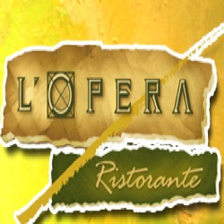
L’Opera Ristorante
101 Pine Avenue, Long Beach, CA
562-491-0066
L’Opera is an Italian restaurant that serves handmade pastas, grilled meats and other Northern Italian fare. The atmosphere is sophisticated and they offer lunch, dinner, dessert and happy hour menu. They have a large list of wines to accompany their large and quality portions.
Average Cost of Meals: $11-43, Prix Fixe Menu (3-5 course meals)- $40-85
Distance from Westin Long Beach Hotel: 0.4 mile

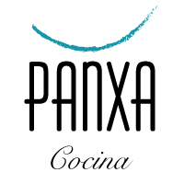
Panxa Cocina
3937 E Broadway, Long Beach, CA
562-433-7999
Panxa is a trendy bar/eatery offering seasonal Mexican fusion plates, Southwestern cuisine, top shelf tequila and weekend brunch. They offer everything from empanadas to grilled fish and have a wide range of specialty cocktails.
Average Cost of Meals: $12-30
Distance from Westin Long Beach Hotel: 2.7 miles

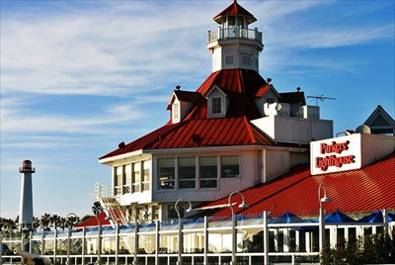
Parkers’ Lighthouse
435 Shoreline Village Drive, Long Beach, CA
562-432-6500
Parkers’ Lighthouse offers mesquite-grilled seafood, sushi, and steaks. There is a beautiful view of the harbor and live music to make it a wonderful spot to experience Long Beach cuisine. Their robust wine list, housed in their two-story wine cellar, received the Wine Spectator’s Award of Excellence. They are known for their innovative Southern California Seafood dishes.
Average Cost of Meals: $15-98
Distance from Westin Long Beach Hotel: 1.0 mile
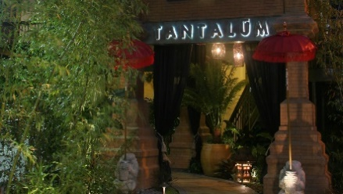
Tantalum Restaurant
6272 E Pacific Coast HWY #J, Long Beach, CA
562-431-1414
tan-ta-lum: Number 73 on the Periodic Table of Elements; non-corrosive metal found by the sea, known for its inability to absorb negative elements from its surrounding environment. Tantalum is an exotic restaurant on the waterfront. They offer New American fare with some Asian twists. They have an extensive drink menu and offer a little something for everyone.
Average cost of meals: $13-48
Distance from Westin Long Beach Hotel: 5.4 miles

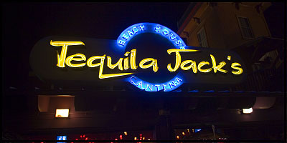
Tequila Jacks Restaurant and Cantina
407 Shoreline Village Drive, Long Beach
562-628-0454
Refined dining rooms serving Mexican fare & cocktails. There is a waterfront deck with beautiful views of the harbor. They offer over 100 types are Mexico’s finest Tequilas.
Average cost of meals: $12-22
Distance from Westin Long Beach Hotel: 0.7 mile

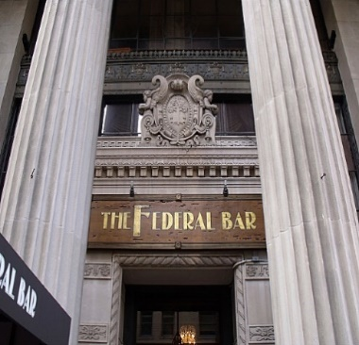
The Federal Bar
102 Pine Ave, Long Beach
562-435-2000
The Federal Bar is a hop gastropub in a former banking building with high ceilings and chandeliers offers bar food and drinks. They offer foods from burgers and hot dogs, to delicious salads, and bowls. Their bar menu offers a variety of drinks.
Average price of meals: $9-26, Prix Fixe- $35-55 *additional option of open bar
Directions from Westin Long Beach Hotel: 0.4 mile
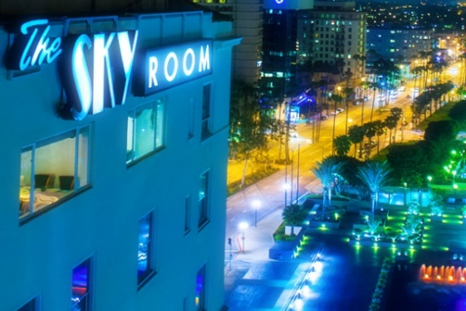
The Sky Room
40 S Locus Avenue, Long Beach
562-983-2703
The Sky room is an art deco hotel bar/eatery offering New American fare and city views plus music and dancing on the weekends. This upscale restaurant has consistently received Open Table’s Diners’ Choice Awards for Best Overall restaurant. For years, they have been the ideal seafood and steakhouse restaurant for thousands people.
Average price of meals: $32-59. Prix Fixe Menu- $69-99 (no alcohol), $155 (well drinks included)
Directions from Westin Long Beach Hotel: 0.2 mile

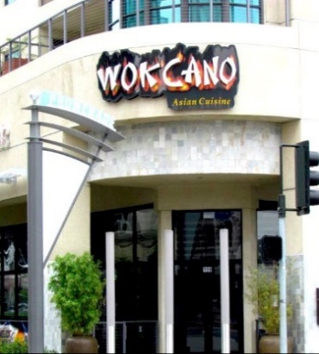
Wokcano
199 The Promenade N, Long Beach
562-951-9652
Wokcano is a hip chain outpost for Asian-fusion fare, sashimi and sushi. Their eclectic décor and huge sushi list makes for a unique evening. You can choose to sit in their intimate indoor spaces or their casual outdoor patio. They have a popular happy hour with a well-rounded drink menu and appetizers.
Average price of meals: $11-59
Distance from Westin Long Beach Hotel: 0.3 mile

